Andy Cherney

11/13/2023

Week7Meet - 10 pts

Turn in on BBL as soon as complete, but before end of day Sunday following the lecture.

Answer these questions as we progress through the meeting.

1. What code in Great Lakes Shipping is common among all shipping vehicles?

Attributes range and capacity with its getters and setters

* load (Pallet) : bool
* unload(Pallet) : Pallet

1. What would be a good identifier for the parent class of which Van, Boat and Truck are the children?

Vehicle

Van, Boat, Truck all extend vehicle

1. Design an inheritance tree for the things that Great Lakes ships. Start with boxes with class names, then add data to the boxes until you have UML diagrams. (You can paste a photo of what you did on paper)

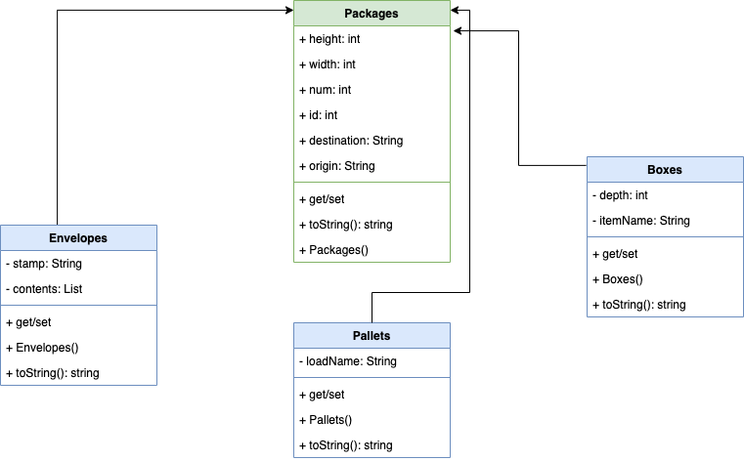

1. Your breakout room partners: Brett, Sohan, and Roy  
   Your component: Shows  
   Your resultant hierarchy (photo is fine):

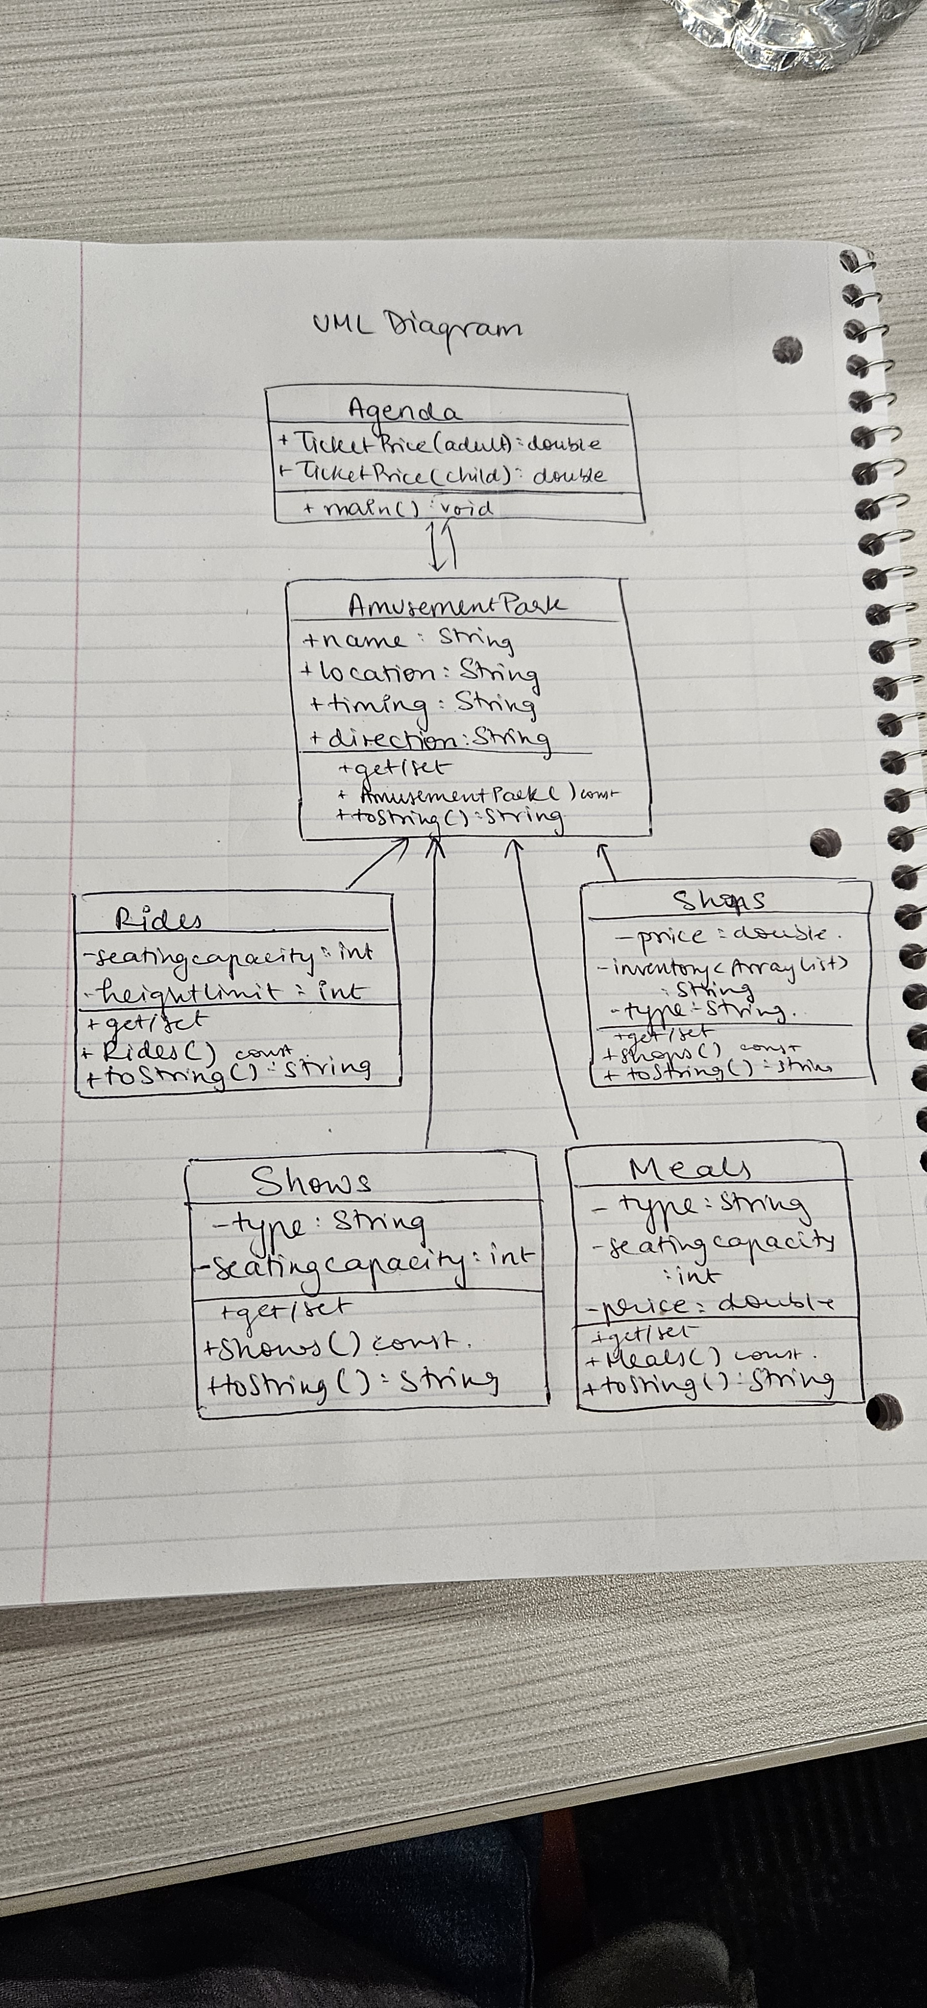

1. Summarize your understanding of the “Resolving Differences” step:

We must look at the hierarchies developed and then see if any variables and methods should be changed to make sure everything is common across the program.

1. Write a loop that makes use of polymorphism for the Great Lakes Shipping program:

ArrayList <Package> packages = new ArrayList();

for (Package p : packages) {

System.out.println(p);

}

Reflect on your learning and your needs. After this class meeting, what topics do you feel like you learned and what topics do you feel like you need more information on to learn?

I learned about how inheritance works in Java. I learned how hierarchies work and how the child class works when inheriting methods and variables from the parent class. I still need to understand better how polymorphism works and variable shadowing.